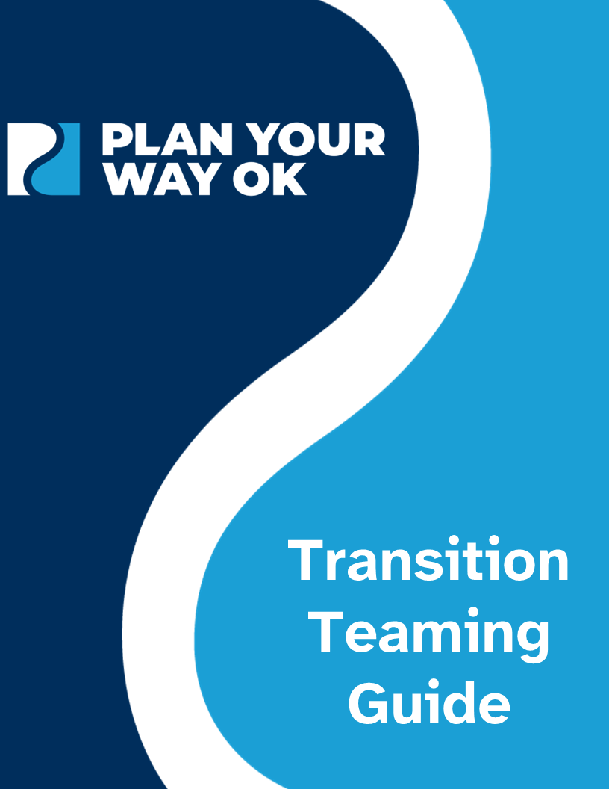
Transition Teaming Guide

Table of Contents
Pathways to Partnerships – Transition Teaming Guide 1
Collaborative Teaming Checklist 1
Ongoing Collaborative Teaming Checklist 2
Getting Started, Collaborative Teaming, and Considerations 3
Transition Team 3
Serve 3
Service Area 4
Membership Considerations 4
Roles and Responsibilities 5
Team Leadership Responsibilities 5
Team Member Roles 5
Team Member Contact Information 6
Meeting Time, Dates, and Location 7
Information Sharing 7
Meetings 7
Needs Survey 8
Meeting Agenda 8
Map Out the Year 9
Goal Setting 10
Meeting Ideas 10
Event Ideas 11
Event Responsibilities 11
Speaker Ideas 11
Wrapping Up the Year 12
Resources and Examples 12

Pathways to Partnerships – Transition Teaming Guide

Comprehensive resource for strengthening existing transition teams and forming new teams.
- Guidance on how to effectively form a new team and guidance through each step of the process, including defining roles, goal setting, and establishing procedures.
- Practical ideas for teams, including checklists, meeting agendas, and feedback forms.

Collaborative Teaming Checklist

When forming a new team or enhancing an existing one, follow these guidelines for a detailed exploration of this process to set yourself up for success.

Action | Status
Identify one or two team members to fill the role of team leader(s). | ☐
Determine the type of team and the area the team will serve. | ☐
Use resource mapping to identify schools, technology centers, and agencies within the area of service. | ☐
Invite Local Education Agencies (LEAs) personnel to participate on the team. | ☐
Identify additional outside agency representatives who will participate on the team. | ☐
Identify and understand each team member’s roles and responsibilities. | ☐
Create a list of team members’ contact information. | ☐
Discuss and agree on a meeting date, time, and location. | ☐
Communicate with administration and potential agency members about the team's existence and its associated vision, purpose, and goals. | ☐
Develop an ongoing process for information sharing. | ☐

Ongoing Collaborative Teaming Checklist

Once your team is established, use this action plan to progress through the school year.

Action | Status
Schedule meetings for the year and send appropriate links. | ☐
Send out a needs survey to parents and other stakeholders. | ☐
Utilize an agenda for each meeting. | ☐
Map out events for the school year. | ☐
Assess transition programming, set goals, and make an action plan using the ASAP Assessment and Planning Guide. | ☐
Plan events, resource fairs, parent nights, and training opportunities. | ☐
Delegate responsibilities for each event. | ☐
Invite guest speakers to meetings. | ☐
Plan to attend the Oklahoma Transition Institute. | ☐
Complete end-of-year activities by reviewing progress towards goals and planning for the future. | ☐

Getting Started, Collaborative Teaming, and Considerations

The purpose of this guide is to support the development of transition teams and interagency collaboration, aiming to improve student outcomes in the areas of competitive integrated employment, postsecondary education and training, independent living, community participation, and self-advocacy.

What Are Transition Teams? | What Do Transition Teams Do?
Group of individuals working toward positive postsecondary outcomes for individuals with disabilities, serving | Collaborate across agencies to better coordinate services, empower students and families, disseminate information, and educate professionals to support youth and young adults with disabilities and their families in achieving their desired goals.

Transition Team

Establish one or two transition member(s) to lead the team.
- Leader(s) may be from the local education agency, service provider agency, community partner, or other relevant stakeholders.
- Individual(s) will be responsible for leading the team toward accomplishing their goals.

Serve

Commit to improving transition services for individuals with disabilities.
- Transition team will provide time, skills, and resources to enhance postsecondary outcomes for transition-aged youth and young adults.
- Members will provide ongoing support through collaboration and resource connection.

Service Area

Determine your area of service, considering the local district(s), city, county, and region.
- Reach out to the OK Transition Council’s Transition Team Coordinator.
- Gather contact information for your area, considering school districts, technology centers, and external agencies.
- Map community resources to identify local jobs, agencies, and services to help build transition plans and work experiences that align with a student's post-education goals, interests, and needs.

Membership Considerations

Use the National Technical Assistance Center on Transition: The Collaborative (NTACT:C) Predictor of Implementation School or District Self-Assessment’s (PISA) Instructions and Action Planning Guide. Review the guide online (PDF, 604 KB).

Local Education Agency | Outside Agencies
K-12 Special Educators | Career Tech and Higher Ed Staff
General Education Teachers | Developmental Disability Services
Counselors | Department of Rehabilitative Services
Site and District Administrators | Pre-Employment Transition Specialists
Paraprofessionals | Mental Health Professionals
Parents | Service Provider Agencies
Students | Community Stakeholders
Related Service Providers | Centers for Independent Living

Roles and Responsibilities

Each role within the team is vital to success. Team leaders guide and support fostering a positive and productive environment. Team members contribute by actively engaging and completing tasks to help the team achieve its goals. Together, these roles create a foundation for collaboration and progress.

Team Leadership Responsibilities

Provide guidance, support, and leadership to the team by creating a productive, positive environment.
- Schedule, plan, and run meetings.
- Create team email.
- Communicate with the team regularly about transition opportunities.
- Identify team member responsibilities for meetings and events.
- Monitor team performance.
- Host activities and events.

Team Member Roles

Assist the team in accomplishing goals by being responsible for a specific position and task. Depending on your team, you may not require certain roles. Example roles can include but are not limited to:
- Team Facilitator – guides the group and provides direction.
- Note-Taker – completes the ASAP with input from the team.
- Procedural Technician – ensures team members have supplies.
- Encourager – affirms, supports, and praises team efforts.
- School Liaison – disperse information among staff.
- Events Coordinator – plans and volunteers at events.
- Social Media Manager – regularly updates social media accounts.
- Community Liaison – communicate with community agencies.

Team Member Contact Information

Maintain a contact list with team member information in a shared document, such as Google Drive or OneDrive, to facilitate coordination, communication, and networking.

Team Member | Role | Number | Email

Meeting Time, Dates, and Location

Consider what methods work best for the team.
- Time – possible right after school, within the contract time of team members.
- Dates – choose a consistent time, such as the 2nd Tuesday or every other week.
- Location – if meetings are held virtually, ensure all members have access. If meetings are held in person, include a remote option as well.
- Communicate through email when not meeting and collaborate on documents between meetings.
Open communication is essential for building trust, aligning goals, enhancing collaboration, reaching more students and families, and fostering relationships.

Information Sharing

Maintain an ongoing and effective process for sharing information.
- Determine who needs to be involved in the information sharing process and what their responsibilities are regarding that information.
- Establish communication channels, forming mail groups, utilizing collaborative meeting tools, and creating social media accounts.
- Define the goals of the information-sharing process, including what needs to be shared and the desired outcomes.

Meetings

The purpose of team meetings is to share information, assess transition programming, set goals, make decisions, solve problems, plan and coordinate activities, provide feedback, engage in discussions, and foster relationships.
- Be consistent with meeting times and locations.
- Send calendar invites with reminders for upcoming meetings.
- Make sure to include the online platform link (e.g., Zoom, Teams).
- Adhere to the schedule and utilize the time efficiently.

Needs Survey

Utilize a needs survey to determine the needs of your service area. The results may guide future action.
- Distribute survey to team members, families, students, teachers, agencies, and other key stakeholders.
- Use results to determine gaps, needs, and identify team members.
- Determine suitable solutions for the identified needs and priorities.

Meeting Agenda

Implement an agenda to assist with the planning process, serve as a guide during the meeting, and maintain a record of the meeting.
- Prepare the team for items to be discussed by sending an agenda prior to the meeting.
- Utilize the agenda to stay on track during the meeting and for taking notes.
- Send agenda with notes after the meeting for those who were not in attendance and those with actions to complete.

Map Out the Year

Map out the year’s events and activities. List ideas to consider in each part of the year. Consider other school activities and events that might hinder attendance, etc.

Fall | Winter | Spring | Summer

Goal Setting

Set one to two SMART Goals using the ASAP Assessment and Planning Guide for the team’s focus across the year. SMART Goals are:
- Specific – referring to elements that clearly define what will be done, with more specific goals answering the questions of Who, What, When, Where, and How.
- Measurable – referring to the observable and countable evidence demonstrating the goal accomplished the intended outcome.
- Achievable – referring to the ability to implement the activity within local constraints, including the political climate, available resources, and commitment of the Local Education Agency (LEA).
- Results-Focused – referring to a focus on outcomes achieved from the goal as opposed to the process. For example, counting the number of students who received training on the Self-Determined Learning Model of Instruction (SDLMI) is process-focused. Determining whether students can adequately use the SDLMI to set and attain goals is results-focused.
- Time-Bound – referring to an established timeline in which progress can be measured.

Meeting Ideas

- Map out the year and planning session
- Create a needs survey and review the results.
- Assess transition programming.
- Set goals and develop an action plan.
- Host a Department of Rehabilitation Services (DRS) information session.
- Share transition resources.
- Review transition assessments.
- Invite inclusive postsecondary education (IPSE) programs to present.

Event Ideas

- Transition resource fair. Review the Transition Fair Guide (PDF, 12.9 MB).
- Guardianship information session.
- Department of Rehabilitation Services (DRS) information session.
- Adult education programs preview.
- Transition curriculum night.

Event Responsibilities

- Event Coordinator – oversees the entire event-planning process.
- Venue Manager – book venue and manage set up and tear down, ensuring compliance with venue policies.
- Marketing and Communication – promote the event and manage communication, create flyers, and handle social media presence.
- Donation Coordinator – secure donations for the event.
- Event Volunteer – assist with set up and tear down, registration tables, door prizes, and food distribution.

Speaker Ideas

- Inclusive Postsecondary Education Representative
- Department of Rehabilitation Services Provider
- Special Education Coordinator
- Parent Advocate
- Student Advocate
- Higher Education Disability Services Coordinator
- Community Support Program Representative
- Developmental Disabilities Services Representatives
- Pre-Employment Transition Service

Wrapping Up the Year

- Debrief
- Review goals and action plan, adjusting goals as needed.
- Consider the team’s plan for Years 1, 3, and 5.
- Put the first meeting of next year on the calendar.

Resources and Examples

Resources and examples will become available in a shared Google Drive. This drive will be updated as we collect and compile resources from the community. Access the resources online. If you would like to contribute materials, please contact us at planyourwayok@gmail.com.

The contents of this guide were developed under grant HR421E230012 from the U.S. Department of Education (Department). The Department does not mandate or prescribe practices, models, or other activities described or discussed in this document. The contents of this guide may contain examples of, adaptations of, and links to resources created and maintained by another public or private organization. The Department does not control or guarantee the accuracy, relevance, timeliness, or completeness of this outside information. The content of this guide does not necessarily represent the policy of the Department. This publication is not intended to represent the views or policy of or be an endorsement of any views expressed, or materials provided by any Federal agency. (EDGAR 75.620)

