

Collaboration Guide: Department of Rehabilitation Services and Local Education Agencies
Department of Rehabilitation Services and Local Education Agencies
Collaboration Guide

Glossary of Acronyms

AT: Assistive Technology
CAP: Client Assistance Program
CIL: Centers for Independent Living
CTE: Career and Technology Education; Career and Technical Education
DDCO: Developmental Disabilities Council of Oklahoma
DDS: Developmental Disabilities Services
DHH: Deaf and Hard of Hearing
DRS: Department of Rehabilitation Services
IDEA: Individuals with Disabilities Education Act
IEP: Individual Education Program
IPE: Individual Plan for Employment
IPSE: Inclusive Postsecondary Education
LEA: Local Education Agency
MSG: Measurable Skill Gains
NCDET: National Center for Disability Education and Training
NTACT-C: National Technical Assistance Center on Transition: The Collaborative
OKSA: Oklahoma Department of Human Services–Oklahoma Successful Adulthood Program
OP2P: Oklahoma Pathways to Partnerships
OSB: Oklahoma School for the Blind
OSD: Oklahoma School for the Deaf
OSDE-SES: Oklahoma State Department of Education–Special Education Services
PIP: Partners in Policymaking
Pre-ETS: Pre-Employment Transition Services
PYWOK: Plan Your Way OK
SBVI: Services for the Blind and Visually Impaired
SEA: State Education Agency
SPIN: Strengths, Preferences, Interests, and Needs
VR: Vocational Rehabilitation
WIOA: Workforce Innovation and Opportunity Act
YLF: Youth Leadership Forum

Table of Contents

Glossary of Acronyms ii
Table of Contents iii
Introduction 1
Department of Rehabilitation Services (DRS) 1
Special Education Services 2
Purpose of Partnerships 2
DRS Services 3
Pre-Employment Transition Services (Pre-ETS) 3
Additional DRS Services 4
Referrals and Applications to DRS 5
Navigating the DRS Referral Process 5
Who can refer students? 5
Who should be referred? 5
When should a referral be made? 6
What is the referral process? 6
Identifying the DRS Point of Contact 6
Navigating the Application Process 6
Practical Strategies for Success 7
Effective Approaches from Educators 7
Effective Approaches from VR Counselors 8
IEP to IPE: Aligning Special Education and Vocational Rehabilitation 9
Comparing Regulations and Policies in Special Education and DRS Services 9
Target Population and Timeline 9
Implement Joint Planning Meetings 10
IEP & IPE Components Hyperlinked to Code of Federal Regulations (eCFRs) 10
IEP–IPE Connection Points 11
Including IEP Transition Services in the IPE 11
IEP–IPE Coordination Process for the LEA 12
Pre-ETS Supports Post-School Goals in the IEP and IPE 12
Resources 13
Important Links 13
Services 13
Agencies 18
References 20

Introduction

The Oklahoma Department of Rehabilitation Services Collaboration Guide was developed through the Oklahoma Pathways to Partnerships (OP2P) grant, a joint initiative supported by the Oklahoma State Department of Education–Special Education Services (OSDE-SES) and the Oklahoma Department of Rehabilitation Services (DRS). Its purpose is to strengthen collaboration between educators, vocational rehabilitation professionals, and community partners who support students with disabilities in their transition from school to adult life.

This guide outlines how DRS and schools (hereinafter, Local Education Agencies, or LEAs) coordinate services under the Individuals with Disabilities Education Act (IDEA) and the Workforce Innovation and Opportunity Act (WIOA). It provides clear guidance on referral processes, shared responsibilities, and best practices for communication and planning. By fostering early, coordinated, and outcome-focused collaboration, schools and DRS can help students with disabilities prepare for postsecondary education, competitive employment, and independent living.

Department of Rehabilitation Services (DRS)

The Oklahoma Department of Rehabilitation Services (DRS) is Oklahoma’s vocational state agency. Vocational Rehabilitation (VR) is the process of assisting individuals with disabilities in overcoming barriers to employment and independent living. DRS helps people with disabilities prepare for, obtain, and maintain employment, as well as live as independently as possible. In this guide, “DRS” and “VR” are used interchangeably.

DRS follows two main federal laws. The Rehabilitation Act of 1973 requires DRS to provide vocational rehabilitation services, including assessments, counseling, training, and support, that help people reach their employment and independent living goals. The Workforce Innovation and Opportunity Act (WIOA) updated and strengthened the Rehabilitation Act, with a particular emphasis on supporting students and youth with disabilities.

WIOA promotes early and coordinated transition planning for students moving from LEAs to postsecondary education or employment, in accordance with legislative documents. This includes the provision of Pre-Employment Transition Services (Pre-ETS) for potentially eligible students with disabilities.

Key components of WIOA include:
- Pre-Employment Transition Services (Pre-ETS): Offered to students with disabilities ages 14 to 21 and includes job exploration, work-based learning experiences, counseling on post-secondary education, workplace readiness training, and self-advocacy instruction
- Collaboration: Requires coordination between DRS agencies, schools, and other partners to ensure seamless services
- Outcome-Oriented Services: Designed to prepare students for competitive, integrated employment (CIE) or further education
- Expanded Youth Services: Provides career counseling, job placement, and support services for youth with disabilities up to age 24.

Overall, WIOA strengthens transition services by promoting early intervention, cross-agency collaboration, and a focus on achieving meaningful post-school outcomes.

Special Education Services

The Oklahoma State Department of Education-Special Education Services (OSDE-SES) oversees Local Educational Agencies' (LEAs) implementation of the Individuals with Disabilities Education Act (IDEA). The IDEA is the federal law that mandates special education through an Individualized Education Program (IEP) for qualified students with disabilities. IDEA requires schools to provide coordinated transition services to transition-aged students with disabilities who have an IEP. Transition services must be individualized and bridge the gap between school and adult life, focusing on each student’s postsecondary goals in education, training, employment, independent living, and community participation (if appropriate).

These services must be based on the student’s strengths, preferences, interests, and needs (SPIN) and may include, but are not limited to:
- instruction,
- related services (if needed),
- community experiences,
- development of employment and post-school adult living objectives,
- acquisition of daily living skills (if appropriate), and
- a functional vocational evaluation (if appropriate).

According to the Oklahoma State Department of Education, Office of Special Education Services (OSDE-SES, 2024), secondary transition services must begin no later than the beginning of the ninth-grade year, or by age 15, whichever comes first. Students must be invited to their IEP meetings when transition services are discussed and if they do not attend, their preferences and interests must be considered. They should take an active role in transition planning. If another agency, such as DRS, is likely to provide or pay for transition services, the school must also invite the agency with the parent’s consent or the student’s consent if they are 18 or older. (20 U.S.C. 1416(a)(3)(B)).

Purpose of Partnerships

Both IDEA and WIOA emphasize that transition services must be a coordinated, outcome-focused process. Supporting students and youth with disabilities as they move into adulthood requires active student participation, strong family involvement, and collaboration across agencies. Partnerships between DRS agencies, State Educational Agencies (SEAs), and Local Educational Agencies (LEAs) are essential to:
- align services and goals,
- provide seamless supports, and
- improve post-secondary outcomes

The National Technical Assistance Center on Transition: The Collaborative (NTACT:C) has identified interagency collaboration as a strong predictor of post-school success. The purpose of this guide is to strengthen collaboration and communication between DRS and LEAs to improve transition outcomes for students with disabilities.

DRS Services

Pre-Employment Transition Services (Pre-ETS)

Pre-ETS services may include, but are not limited to:
- Job Exploration: exploring the world of work and career options; skills assessments and interest inventories, labor market, and in-demand occupation information
- Work-Based Learning: exploring appropriate workplace behaviors, participating in work-site tours, and job shadowing experiences
- Workplace Readiness: preparing students for the workplace; soft skills training, peer mentoring, independent living skills, and accessing transportation
- Self-Advocacy: helping the student learn more about themselves, their disabilities, and how to present themselves responsibly; recognize their strengths and how to advocate for their needs and develop strategies for goal setting, time management, and problem solving
- Post-Secondary Counseling: exploring options for students seeking careers that require postsecondary education or training

Pre-ETS must be made available statewide to students who meet the definition of a “student with a disability” who may need such services and are either:
- eligible for DRS services, or
- potentially eligible for DRS (i.e., all students with disabilities, including those who have not applied or have applied and been determined eligible for DRS services).

Pre-ETS helps students with disabilities successfully move from high school to further education or meaningful employment. These short-term services focus on building workplace readiness by providing opportunities to develop job skills, gain real-world work experience, and explore postsecondary training options that may lead to industry-recognized credentials.

Pre-ETS serves as the first step in DRS services, giving students the chance to begin identifying career interests that can later be expanded through individualized DRS services and transition planning. To be eligible, students must have a disability and demonstrate a need for these services.

In Oklahoma, Pre-ETS are provided by the Department of Rehabilitation Services in partnership with local school districts, the National Center for Disability Education and Training (NCDET) at the University of Oklahoma Outreach, Central Technology Center, and Kiamichi Technology Center. The goal of these services is to encourage early career exploration while promoting independence, community integration, continued education, and successful entry into competitive, integrated employment.

Additional DRS Services

DRS Transition services offer students with disabilities who are eligible for Vocational Rehabilitation (VR) Services (including Deaf and Hard of Hearing (DHH)) or Services for the Blind and Visually Impaired (SBVI) a variety of job-related services. Students may apply at age 15 ½ and, if they qualify, receive transition-specific services from ages 16 through 22. Services are documented in the Individual Plan for Employment (IPE). The IPE is a personalized, written employment plan co-created by the individual and a qualified DRS counselor. It sets a clear job goal, outlines needed services, and is grounded in the individual’s strengths and choices. The IPE must be developed within 90 days of the date of eligibility determination and reviewed annually. DRS clients (students) must contact their VR counselor every 60 days, and the IPE should be reviewed and updated as needed.

DRS works in partnership with Oklahoma schools to provide transition services. This is done in accordance with the IDEA, Section 504 of the Rehabilitation Act of 1973, and the WIOA. Examples of DRS services include, but are not limited to:
- Vocational Counseling and Guidance: Through direct contact, the DRS counselor assists teachers, parents, and students in developing appropriate career goals.
- Vocational Assessment and Evaluation: Identifies students’ employment-related strengths and interests and recommends potential career fields to explore.
- After graduation, DRS counselors and students, now referred to as clients, continue to work toward vocational and employment goals. Some services, based on basic living requirements, are available to eligible individuals without charge. At this point, individuals may be asked to share the cost of some services, depending on income and financial resources.

Potential Student Outcomes:
- Alignment of the IEP and the IPE.
- Enhanced self-advocacy skills and student-led IEP and IPE meetings.
- Increased family engagement around post-secondary education and employment opportunities.
- Increased student participation in work-based learning experiences that match their postsecondary education interests before high school graduation.
- Increased opportunities for students with disabilities to explore post-secondary training options, leading to more meaningful post-secondary employment and training goals in the IEP.

Educators are encouraged to actively partner with VR counselors and field representatives to provide personalized services that meet each student’s unique needs. By working together, services, resources, and opportunities that set students up for long-term success can be tailored to meet each student's needs. Let’s collaborate and build a pathway to brighter futures for all!

Educators and DRS staff should refer to the Side-by-Side View: Transition Services (https://transitionta.org/sidebyside) as a quick reference tool to compare transition services under Pre-ETS, Vocational Rehabilitation (VR) Transition Services, and the IDEA. This easy-to-read and helpful resource clarifies definitions, target populations, service scope, and responsibilities across agencies.

Referrals and Applications to DRS

Navigating the DRS Referral Process
Helping students with disabilities achieve career and educational goals begins with a referral to DRS. Referrals connect students with disabilities and families with their local VR counselor.

Who can refer students?
Anyone involved in a student's educational journey can help connect them with valuable resources. Special education professionals, guidance counselors, school nurses, psychologists, speech-language pathologists, administrators, general education teachers, parents, Pre-ETS specialists, and authorized representatives are all encouraged to make referrals. Students with parent support can also fill out a self-refer online by visiting the Self-Referral Portal (https://oklahoma.gov/okdrs/self-refer). Someone from DRS will contact them to initiate the application process. Let’s work together to empower every student!

Who should be referred?
Students with an IEP, a 504 Accommodation Plan, or a disability under Section 504 (even without a formal plan) may be referred. This may include at-risk youth (who must be released and ready for employment before application), individuals experiencing homelessness, those in foster care or group homes, adjudicated youth (who must be released and prepared for employment before application), and others facing barriers to employment. If a student is not currently on an IEP or 504 plan but demonstrates impairments that are barriers to employment, DRS can provide referrals for evaluations to determine eligibility for services. We're here to support all students in need!

When should a referral be made?

Students may be referred at 15 ½ to begin the process of engaging in transition services through DRS.

What is the referral process?

In Oklahoma, the DRS Referral is included in the IEP process for transition-age students. Upon receiving the parent’s consent (i.e., using the Consent for Release of Confidential Information), special educators should complete a DRS Referral (Voc. Rehab.) form for each student, regardless of disability level, during the school year that the student is 15 years of age and prior to them turning 16 (around 15 ½ years old).

The DRS Referral and Consent for Release of Confidential Information forms are submitted, via email, mail, or hand delivery, to the local VR counselor. If a student is not referred to DRS, the special educator documents the reason, such as the parents did not consent, or the student is too young for the IEP.

The DRS referral process is designed to be efficient and collaborative. Referrals should be sent directly to the assigned VR counselor or tech. Once a referral is received, contact will be made within 30 days. To ensure a smooth experience, it’s essential to work closely with the assigned VR counselor to determine the best process for your school.

Identifying the DRS Point of Contact

- Office Locator: Find an office at https://oklahoma.gov/okdrs/students/hs-locator.
- DRS Staff Assignments: Contact TransitionTeam@okdrs.gov to have the link emailed to you or visit our website (https://bit.ly/48S7yz6).

Navigating the Application Process

- Provide parents with the contact information of the VR counselor and a DRS application (printed or email versions).
- Support the parents in calling the office to schedule an appointment.
- Assist them in filling out the application, if needed.
- Encourage the parents to gather as much medical or disability-related information as possible to bring to the appointment.
- Remind them to attend the scheduled appointment to finalize and submit the application.

Some students and families may hesitate to consent to a referral or apply for DRS services because they worry about losing their disability benefits. It is essential to reassure them that:
- Many individuals who receive Supplemental Security Income (SSI) or Social Security Disability Insurance (SSDI) can still work and maintain benefits.
- DRS counselors can explain how work incentives and benefits planning function, helping families make informed decisions.

Practical Strategies for Success

Frequent communication between school staff and DRS counselors and techs is crucial for successful student outcomes. Schools must obtain parent or adult student consent to refer students to DRS and for DRS counselors or techs to attend IEP meetings. DRS must also have parent or adult student consent to obtain high school transcripts and report cards for eligible students to collect and report Measurable Skill Gains (MSG) for youth at the end of each semester (WIOA requirement).

Establishing a consistent process for referrals, applications, parental or student consent, and meetings strengthens the overall transition planning process. It enables staff from both agencies to communicate more clearly and efficiently with students and families, ensuring that everyone stays informed and involved. In addition, setting a regular day or time for transition-related meetings allows school staff and VR counselors to plan, which improves consistency, attendance, and collaboration.

Working together on a district or regional transition team is an excellent way to connect service providers, set local goals, and plan local transition activities like Resource Nights or Transition Fairs.

Effective Approaches from Educators
- Provide information about DRS to students and parents in a variety of ways.
  - Show students and parents a short video about DRS services.
  - Provide handouts, brochures, checklists, and other written information.
    - Materials are available from your VR counselor, with downloadable files at the DRS website (https://oklahoma.gov/okdrs).
- Share school safety protocols with counselors and techs to ensure safe and efficient access.
- Share school calendars and daily class and bell schedules.
- Provide consistent meeting space and safe storage for personal items.
- Invite a counselor or tech to attend IEP meetings with plenty of notice (2-3 weeks, if possible).
  - Establish a consistent meeting day or time that both parties can be available, such as afternoons on the 1st and 3rd Monday of the month.
  - Attempt to schedule meetings during those designated times when possible.
- Invite counselor or tech to participate in parent-teacher conferences (with consent), if possible, 2-3 weeks' advance notice.
- Work with counselors to set up annual consent procedures to obtain transcripts and report cards for eligible students.
- Take advantage of the DRS Digital Backpack (http://bit.ly/41mJz6p), a free transition toolbox of curriculum and activities.

Effective Approaches from VR Counselors

- Attend IEP meetings of DRS clients.
- Establish regular meeting times with schools, such as afternoons on the 1st and 3rd Monday of the month.
- Obtain DRS release forms (signed by parents or adult students) and share copies with schools.
- Collect transcripts for all students every semester (utilize the C-5 form from DRS to receive this, if necessary).
- Collect invoices and time sheets for School Work Study and Work Adjustment Training students.
- Collaborate with schools on annual consent procedures to obtain transcripts and report cards for MSG documentation.
- Encourage teachers to take advantage of the DRS Digital Backpack (http://bit.ly/41mJz6p), a free transition toolbox of curriculum and activities.
- Obtain copies of transcripts from eligible students.
  - Example: The DRS counselor sends out the following letter to students and encloses a self-addressed postage-paid envelope for the student to return the transcript in the mail to DRS:

Dear [Client],

The first (second) semester of the school year is almost over, and I hope it has been a good semester for you! I am required to document your vocational rehabilitation process each semester. Please provide DRS with a copy of your semester grades. Please return either a high school transcript for (insert the fall or spring semester and the year) or a report card in the enclosed postage-paid envelope, or email it to me at (insert counselor’s email address). Please contact me if you have any questions. Thank you! Everything you do is appreciated as we work to improve outcomes for students with disabilities.

IEP to IPE: Aligning Special Education and Vocational Rehabilitation

Transition planning is most effective when schools and Vocational Rehabilitation (VR) work together. An IEP helps students succeed in school, while an IPE focuses on preparing them for life after graduation. By aligning the IEP with IPE, students gain a clear pathway from classroom learning to meaningful employment. This collaboration ensures that services are not duplicated, that goals are connected, and that each student receives the support needed to reach their fullest potential.

Comparing Regulations and Policies in Special Education and DRS Services

IDEA (34 CFR § 300.320(b) & 34 CFR § 300.43): Transition services. Beginning not later than the first IEP to be in effect when the child turns 16, or younger if determined appropriate by the IEP Team, and updated annually, thereafter, the IEP must include:
(1) Appropriate measurable postsecondary goals based upon age-appropriate transition assessments related to training, education, employment, and, where appropriate, independent living skills; and
(2) The transition services (including courses of study) are needed to assist the child in reaching those goals.

Oklahoma Special Education Services Policy: For students on an IEP, secondary transition services must be in effect before the beginning of the ninth-grade year, or on or before the age of 15, whichever comes first.

WIOA (34 CFR § 361.45(a)(1) & 34 CFR § 361.46(a)(1–3)): An individualized plan for employment meeting the requirements of this section and § 361.46 is developed and implemented in a timely manner for each individual determined to be eligible for vocational rehabilitation services.

Target Population and Timeline

Students with disabilities aged 15 to 21 on an IEP, students with disabilities aged 16+ on an IPE, and students with disabilities aged 14 to 21 who are potentially eligible for Pre-ETS. This may include at-risk youth, individuals experiencing homelessness, those in foster care or group homes, adjudicated youth, and others facing barriers to employment.

Timing:
- The IEP transition services must begin on or before age 15.
- The IPE can begin as early as age 16.
- Pre-ETS for potentially eligible students can begin as early as 14.

Implement Joint Planning Meetings

Schedule coordinated planning meetings. An example could happen at any of the following:
- Initial IEP Meeting
- Annual IEP Review
- IEP Amendment (Addendum)
- Three-Year Reevaluation (Triennial)
- Senior Year Exit IEP or Final Transition Review
The goal is to build toward IPE development aligned with IEP transition goals.

IEP & IPE Components Hyperlinked to Code of Federal Regulations (eCFRs)
IEP Component (IDEA) | IPE Component (WIOA) | OSERS Quotes and Page Numbers
Post-Secondary Goal  (34 CFR § 300.320(b)) | Employment Outcome (34 CFR § 361.46(a)(1)) | p. 11 “…development of employment and other post-school…”
Transition Services  (34 CFR § 300.43) | Planned VR Services (34 CFR § 361.46(a)(2)) | p. 10 “…IDEA are coordinated early  in the transition process with the VR program…”
Student Participation in IEP Meetings  (34 CFR § 300.321(b)(3) | Student Informed Choice in IPE Planning  (34 CFR § 361.45(d)) | p. 5 “…parental consent or the consent of the student who has reached the age of majority…”
Course of Study  (34 C.F.R. § 361.22(b)(2)) | Service Timeline  (34 CFR § 361.46(a)) | p. 14 “…IEP should inform the development of the IPE, and both may be developed in coordination...”
Annual Goals  (34 C.F.R. § 300.320(b)) | General Goal  (34 CFR § 361.46(a)(1)) | p. 5 “…measurable postsecondary goals based upon age-appropriate transition assessments related to training, education, employment...”
Involvement of Outside Agencies  (34 CFR § 300.321(b)(3)) | VR Collaboration  (34 CFR § 361.22) | p. 15 “…it may invite VR program representatives to participate in a transition planning meeting and coordinate the development of a student’s IEP and IPE...”
Standard Diploma Graduation/Exit Date  (34 CFR § 300.102(a)(3)(i))  Alternate Diplomas Graduation/Exit Date  (34 CFR § 300.102(a)(1)) | Employment Outcome (34 CFR § 361.5(c)(15)) | p. 7 “…exceeded the age of eligibility for FAPE under State law or when they graduate from high school with a regular high school diploma...”

Note: eCFR’s content is considered citation-quality for most purposes. The eCFR is an “unofficial” (but accurately replicated) source of the CFR, available online (https://www.ecfr.gov/). The official editions of the CFR, the Federal Register, and the List of CFR Sections Affected (LSA) are available online (https://www.govinfo.gov/).

IEP–IPE Connection Points
IEP (Individualized Education Program) | IPE (Individualized Plan for Employment)
Developed under IDEA; focuses on educational (academic and functional) goals and transition services. | Developed under the Rehabilitation Act (WIOA), it focuses on post-school employment goals.
Includes Present Levels, postsecondary goals, annual goals, transition services, and courses of study. | Includes projected post-school employment outcome, DRS services, and timelines.
May include DRS involvement: Pre-ETS participation, referral, application, and eligibility information. | May incorporate relevant IEP transition services that support employment goals.
Reviewed and updated annually by the IEP team. | Reviewed and updated as needed; must be developed before the student exits school.
Led by the school or LEA; includes DRS counselor when applicable. | Led by the DRS counselor, coordinated with the IEP team and other supports.

Including IEP Transition Services in the IPE

The DRS counselor may consider including transition services outlined in the student’s IEP in the development of the IPE if those services support the student’s employment goal or projected post-school employment outcome. Some IEP transition services may also qualify as pre-employment transition services provided by the local education agency. In such cases, documenting these services on the IPE is appropriate and helps highlight the coordination of joint services.

As an agency, DRS should determine how best to show that the IPE was developed with consideration of the IEP services. One way to demonstrate this is directly through the IPE itself. Education staff may also request a copy of the student’s IPE to ensure alignment with the ongoing IEP and that transition services are implemented collaboratively.

IEP–IPE Coordination Process for the LEA

The LEA should communicate with their Pre-ETS Specialist and VR counselor to identify students with disabilities who are receiving IEP transition services and Pre-ETS services, whether they are eligible or potentially eligible. This ensures that DRS transition services can be incorporated into IEP transition planning as early as possible.

The LEA should develop a plan to coordinate and communicate with its assigned DRS staff regarding potentially eligible students and the levels of support required for each. Information about DRS engagement, including Pre-ETS, application, and eligibility determination for individualized transition services, and participation in individualized transition services, should be incorporated into the Present Levels of Academic and Functional Performance Overall Objective Statements.

- Sample statement of DRS services mentioned in the IEP: Bob and his family were provided with information regarding the supports provided through DRS. Bob has been referred to DRS for pre-employment transition services, and although he has not yet applied for DRS services, he has participated in Pre-ETS job exploration activities, and he is interested in a career pathway that allows him to make good money and work with his hands. Bob is scheduled for a meeting with a DRS counselor during the Fall of 2025 to determine if he should apply for DRS services now or continue to receive Pre-ETS as a potentially eligible student. A Pre-ETS Specialist was invited and attended his most recent IEP meeting.

Pre-ETS Supports Post-School Goals in the IEP and IPE

The results of a student’s performance, progress, and participation in any of the five required Pre-ETS services while they are potentially eligible can be used to:
- Develop post-school IEP goals aligned with transition assessment data.
- Identify a projected post-school employment outcome or employment goal on the IPE once the student applies for and is determined eligible for DRS services.

When a student officially applies for DRS services, the VR counselor will determine eligibility, and the student may continue to receive Pre-ETS. These services can help further explore the student’s interests, abilities, and capabilities, and support solidifying an employment goal while ensuring coordination with the student’s IEP goals and objectives before the student graduates or exits the school setting.

Once the student is determined to be eligible for DRS services and an IPE is developed:
- Each Pre-ETS service to be purchased for or provided to the student must be listed on the IPE.
- Any additional DRS services needed to benefit from Pre-ETS or achieve the employment goal should also be included.

Resources

Important Links

- Plan Your Way OK: https://planyourwayok.com/
- DRS Transition Services: https://oklahoma.gov/okdrs/students/transition
  - DRS Office Locator: https://oklahoma.gov/okdrs/information/office-locator

Services

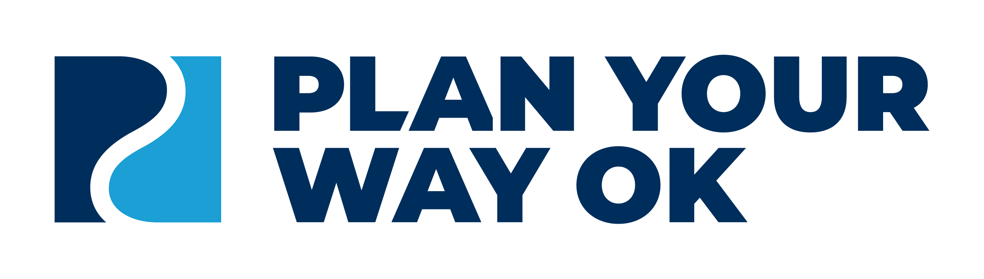
Plan Your Way OK (PYWOK) is a statewide collaborative project funded through the Pathways to Partnerships Disability Innovation Fund (DIF) grant. It is led by the Oklahoma State Department of Education and the Department of Rehabilitation Services. Its purpose is to improve transition education, planning, and services for students with disabilities by fostering partnerships among schools, families, agencies, and businesses. Through shared resources and coordinated efforts, PYWOK helps bridge knowledge gaps among stakeholders to promote successful post-school outcomes, including further education or training, employment, independent living, mental health supports, and community participation.

Stakeholders across Oklahoma can find targeted resources to help them take the next step:
- Students: Discover how to speak up, choose your path after high school, land a job, and live your best life, with PYWOK as your guide.
- Families: Explore community programs, state agencies, and trusted information, all provided in one place to save time, reduce stress, and support your loved one(s).
- Professionals: Strengthen partnerships, share transition events, and access model programs, training, and tools to improve student outcomes.
- Businesses: Learn the benefits of hiring individuals with disabilities and offering work-based learning opportunities, with training and resources to build an inclusive workforce.

DRS helps connect students with disabilities with many resources. The following are examples of some of the resources available to students with disabilities. Information on additional resources is available by visiting the DRS website (https://oklahoma.gov/okdrs/students/transition) or by emailing TransitionTeam@okdrs.gov.
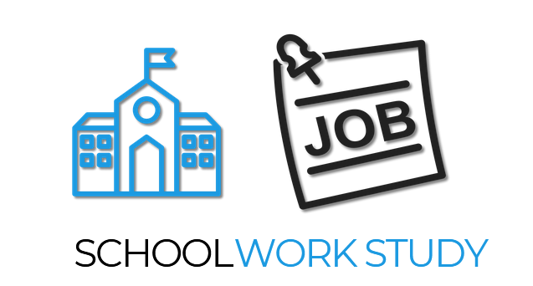
School Work Study (SWS) is arranged through school contracts. From jobs at the school, the district, or the community, students earn job-readiness skills, a minimum-wage paycheck, and high school credits. Utilization of School Work Study requires a contract between DRS and the school or district. For Information on DRS School Work Study contacts, send an email to TransitionTeam@okdrs.gov.

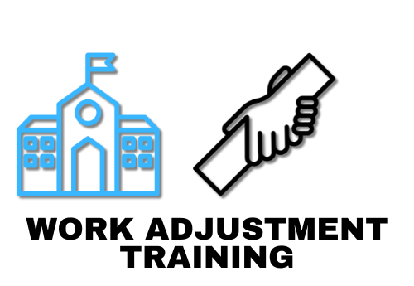
Work Adjustment Training (WAT) is a program that provides jobs through school or community contracts. It gives students a firm foundation in job skills. Because of this, students are better prepared for competitive, integrated employment after high school. Utilization of Work Adjustment Training requires a contract between DRS and the school or district. For Information on Work Adjustment Training contacts, send an email to TransitionTeam@okdrs.gov.

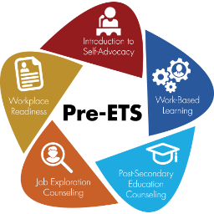
Pre-Employment Transition Service (Pre-ETS) is a career-focused preparation activity for high school students with disabilities, which the Oklahoma Department of Rehabilitation Services makes available to high school students aged fourteen through twenty-one. The activities described below are introductory services intended to help students with disabilities get an early start in identifying career interests to achieve community integration, independence, postsecondary education, and competitive integrated employment.
- Job Exploration: exploring the world of work and career options; skills assessments and interest inventories, labor market, and in-demand occupation information
- Work-Based Learning: exploring appropriate workplace behaviors, participating in work-site tours, and job shadowing experiences
- Workplace Readiness: preparing students for the workplace; soft skills training, peer mentoring, independent living skills, and accessing transportation
- Self-Advocacy: helping the student learn more about themselves, their disabilities, and how to present themselves responsibly; recognize their strengths and how to advocate for their needs and develop strategies for goal setting, time management, and problem solving
- Post-Secondary Counseling: exploring options for students seeking careers that require postsecondary education
Central Tech Pre-ETS: https://centraltech.edu/student-services/employment-services
Kiamichi Tech: https://www.ktc.edu/372123_2
OU Pre-ETS: http://bit.ly/4ntrHPC

Secondary Transition folders provide helpful information about recommended resources, services, and activities for students with disabilities as they prepare for life after high school. There are elementary, middle, and high school versions of folders, each designed for a specific age or grade range. The folders can be accessed online and are available in standard print, large print, Braille-ready, and Spanish formats.

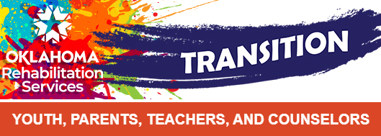
The DRS Transition newsletter is a monthly publication that highlights current transition-related programs, resources, events, partners, and staff in Oklahoma. This newsletter is free and intended for transition-aged youth with disabilities, parents, teachers, counselors, and other interested professionals who work with students with disabilities. This is an effective way to learn about and stay up to date on all things transition in the state of Oklahoma. To sign up for the DRS Transition newsletter, subscribe online at https://public.govdelivery.com/accounts/OKDRS/subscriber/new.

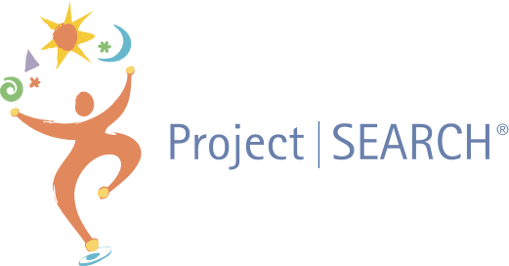
Project SEARCH™ is a business-led, collaborative model that provides employment and education opportunities for high school seniors or post-secondary technology center students with disabilities through a combination of classroom employability skills instruction, career exploration, and on-the-job training and support. This is a yearlong program.

Program partners include a host business, the Oklahoma Department of Rehabilitation Services (DRS), a host school (high school or career technology center), the University of Oklahoma National Center for Disability and Education Training, and a community rehabilitation provider. Program participants must be DRS clients and have a genuine desire to obtain competitive employment upon program completion. For information on establishing a Project SEARCH, please contact Brandi Hurley at bhurley@ou.edu or by phone at 405-482-0829.

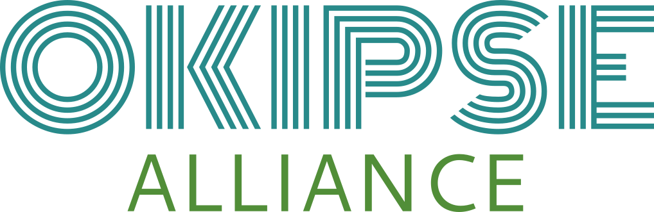
Oklahoma Inclusive Postsecondary Education (OK IPSE) Alliance is a partnership between the Department of Rehabilitation Services, Sooner SUCCESS, and the Oklahoma State Department of Education. This program is focused on ensuring that Oklahoma students with intellectual and developmental disabilities can achieve higher education and participate fully in campus life.

OK IPSE programs are in higher education settings across the state. For answers to questions about OK IPSE Alliance, send an email to Julie Lackey (julie@okipsealliance.org) or visit the website at https://www.okipsealliance.org/.
- Northeastern State University RiverHawks Scholars: http://bit.ly/3JxGCKq
- University of Oklahoma Sooner Works: https://www.ou.edu/education/zarrow/sooner-works
- University of Science and Arts Oklahoma Neill-Wint Center for Neurodiversity: https://usao.edu/future-students/neill-wint-center-for-neurodiversity
- Oklahoma State University Opportunity Orange Scholars: http://bit.ly/4oHC7fq


Located in Muskogee, the Oklahoma School for the Blind (OSB), also known as Parkview School, provides residential and day education, as well as outreach programs, at no charge to Oklahoma children who are blind or visually impaired from infancy through 12th grade. OSB's goal is to help students reach their maximum potential.

OSB offers a comprehensive curriculum of reading, language arts, mathematics, social studies, science, physical education, music, and computer science for residential and day students. Specialized instruction includes braille, orientation and mobility, optimum use of low vision, adaptive equipment and technology, and tactile graphic skills.

The secondary school program includes college preparation, vocational training, and a work-study program. In addition, students may receive assessments, counseling, physical therapy, speech and language therapy, hearing tests, and health care services. Recreational activities include student organizations and interscholastic athletics. For more information on the Oklahoma School for the Blind, please visit their website at https://www.osb.k12.ok.us/.


Located in Sulphur, Oklahoma, the Oklahoma School for the Deaf (OSD) offers residential education, early intervention, and outreach services at no cost for Oklahoma students who are Deaf or hard of hearing, ages 3 to 21.

OSD delivers a comprehensive curriculum including American Sign Language (ASL), English, mathematics, science, social studies, physical education, arts, and technology for residential and day students. Specialized instruction focuses on communication skills, auditory training, speech development, adaptive technology, and independent living skills.

OSD also participates in “Child Find,” a legal mandate to identify and assess students ages 3 to 21 suspected of having a disability, collaborating with local education agencies (LEAs) or conducting evaluations independently. Parents or Guardians who need assistance can call the IEP department at 917-781-8226. For more information on the Oklahoma School for the Deaf, please visit their website at https://www.osd.k12.ok.us/.


Founded in 1999, Tech-Now's mission is to empower students with disabilities to make positive career choices that lead to productive, prosperous lives.

Tech-Now, Inc., partners with schools across Oklahoma to offer a computer applications class that goes far beyond using a word processor and media presentation application. The curricula are designed to meet international and state technology standards with an emphasis on pre-employment transition services.

The activities begin with individual technical skills development for simple assignment projects, and progress into the employment simulation, which requires multiple team members, duty assignments, and team organization. These assignments allow for the development and practice of soft skills and are often the first employment-related skills practice individuals experience.

The final step to Tech-Now’s approach to pre-employment skills development is the micro business. The businesses showcase students’ skills by selling student-created products. Via micro businesses, students also gain some on-the-job experience that will be essential to their first job successes.

They are always interested in adding additional program sites to the Tech-Now family. Schools looking for a computer applications class that is project-based and goes a long way in helping students on an IEP or 504 Plan develop marketable skills can contact: tech-now@hotmail.com.

Agencies


Developmental Disabilities Services (DDS)
Oklahoma Human Services Developmental Disabilities Services (DDS)’s mission is to help individuals with developmental disabilities and their families help themselves to lead safer, healthier, more independent, and productive lives. Developmental Disabilities Services (DDS) serves people aged 3 and up who have a primary diagnosis of intellectual disabilities. DDS services are available to those with intellectual and developmental disabilities who may need more support than what is otherwise available through the school systems or DRS. This can include job placement, on-the-job support, volunteer placement, or center-based opportunities. In addition, DDS offers a slew of services, including but not limited to residential support, therapies, transportation, and assistive technology. All these services are meant to support the individual in becoming as independent as possible. For information on how to apply for DDS services, please use their website at https://oklahoma.gov/okdhs/services/dds/areacontactinfo.

DRS Services for the Blind and Visually Impaired (SBVI)
DRS Services for the Blind and Visually Impaired (SBVI) provides employment and independent living services for individuals who are blind and visually impaired. The primary vocational rehabilitation services are counseling and guidance with job placement. However, other services may also be provided as needed to help an individual compensate for, correct, or prevent disability-based barriers to employment. Learn more on their website at https://oklahoma.gov/okdrs/job-seekers/sbvi.

Oklahoma State Department of Education–Special Education Services (OSDE-SES)
The OSDE-SES website for Secondary Transition provides information, guidance, and support to schools, families, and other transition partners. Review their site for more details at https://oklahoma.gov/education/services/special-education/secondary-transition.

Oklahoma Department of Human Services–Oklahoma Successful Adulthood (OKSA) Program
The Oklahoma Successful Adulthood Program (OKSA) Mission is to empower youth in and from foster care to lead safer, healthier, more independent, and productive lives. More information is available on their website at https://oklahoma.gov/okdhs/services/oksa.

Oklahoma Department of Career Technology Education (CTE)
Oklahoma Career Tech connects students and businesses with training opportunities to help Oklahomans find rewarding careers and support Oklahoma industries. The goal of CTE is to develop a world-class workforce for Oklahoma employers, preparing Oklahomans to succeed in the workplace, in education, and in life. To learn more about programs across the state, visit their website at https://oklahoma.gov/careertech.

Developmental Disabilities Council of Oklahoma (DDCO), Youth Leadership Forum (YLF), and Partners in Policymaking (PIP)
DDCO promotes quality services that empower individuals with developmental disabilities to live, learn, work, play, and engage in their communities. While not a direct service provider, DDCO builds partnerships to improve systems, services, and resources in Oklahoma, enabling people with developmental disabilities to realize increased independence, productivity, integration, and inclusion in the community. It sponsors programs like YLF, a 5-day leadership training for high school students with disabilities, and PIP, an advocacy training for adults, parents, and advocates to influence policy and create change. Visit their website to learn more at https://oklahoma.gov/ddco.

Oklahoma ABLE Tech
ABLE Tech enhances the lives of Oklahomans by providing assistive technology (AT) devices, services, financing, digital accessibility, advocacy, and education. Funded through the AT Act of 1998 (reauthorized in 2022), its programs include Device Loans, Demonstrations, Reutilization, Financial Loans, Digital Accessibility, Training, and Outreach. Learn more at https://www.okabletech.org/.

Oklahoma Client Assistance (CAP) Program
CAP, under the Oklahoma Office of Disability Concerns (not DRS), advocates for individuals with disabilities seeking vocational rehabilitation services. It assists individuals with concerns related to OKDRS/VR or Services for the Blind and Visually Impaired. It also serves individuals who receive services from Centers for Independent Living (CILs), Tribal VR, and other Rehabilitation Act programs, by helping resolve issues through administrative, mediation, legal, and other solutions. Find more information on their website at https://oklahoma.gov/odc/client-assistance-program.

Still have questions about DRS Transition Services?
Email DRS staff at TransitionTeam@okdrs.gov.

References

Individuals with Disabilities Education Act, 20 U.S.C. § 1400 et seq. (2004).
https://sites.ed.gov/idea/statute-chapter-33
National Technical Assistance Center on Transition: The Collaborative (NTACT:C). (n.d.). Side by side
view: Transition services. https://transitionta.org/sidebyside/
Office of Special Education and Rehabilitative Services. (2025, January). Coordinating transition
services and postsecondary access: Guidance on requirements under the IDEA and the
Rehabilitation Act. U.S. Department of Education. https://rsa.ed.gov/
Oklahoma State Department of Education, Office of Special Education Services. (2024, August).
Oklahoma special education policies and procedures. http://bit.ly/3LbbEse
Rehabilitation Act of 1973, 29 U.S.C. § 701 et seq. (1973). http://bit.ly/47tVtxH
Workforce Innovation and Opportunity Act, 29 U.S.C. § 3101 et seq. (2014).
https://www.congress.gov/bill/113th-congress/house-bill/803

The contents of this guide were developed under grant HR421E230012 from the U.S. Department of Education (Department). The Department does not mandate or prescribe practices, models, or other activities described or discussed in this document. The contents of this guide may contain examples of, adaptations of, and links to resources created and maintained by another public or private organization. The Department does not control or guarantee the accuracy, relevance, timeliness, or completeness of this outside information. The content of this guide does not necessarily represent the policy of the Department. This publication is not intended to represent the views or policy of or be an endorsement of any views expressed, or materials provided by any Federal agency. (EDGAR 75.620)

