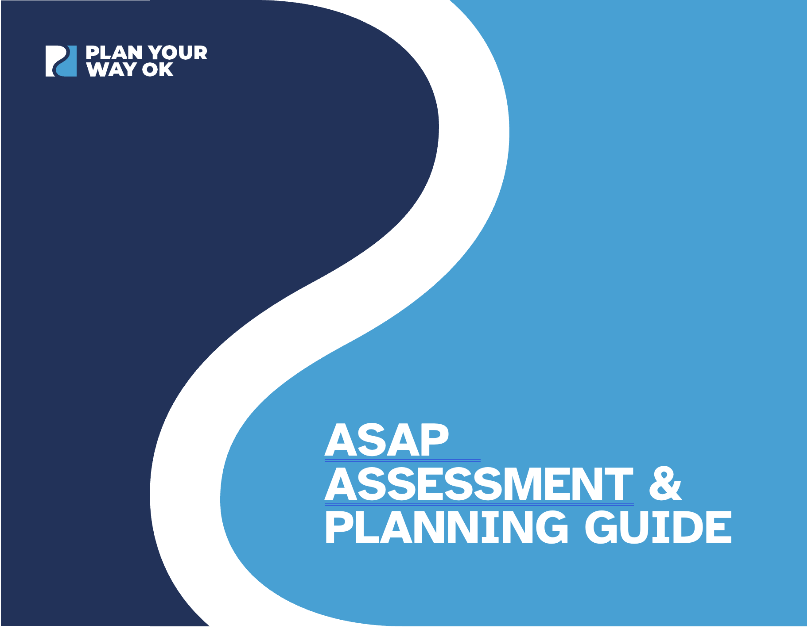
Now that you have established your transition team and become familiar with the Predictors of Post-School Success, it is time to assess your transition programming and services to set goals and make an action plan to improve student outcomes as soon as possible using the ASAP Assessment and Planning Guide.

Assess: Evaluate your transition services and programs.
Set goals: Define clear and measurable goals.
Action plan: Make a detailed action plan to achieve your goals.
Progress-Monitor plans, improve, and ensure positive outcomes.

Assess: Evaluate your current transition services and programs.
You will assess your transition programming and services to determine focus areas using the ASAP Assessment, adapted from the Predictor Implementation School/District Self-Assessment and the Ohio Employment First Transition Framework Predictors Guide.

Teams focused on enhancing adult life outcomes for youth with disabilities can utilize the ASAP Assessment to:
- Conduct an inventory to identify the presence or absence of key Predictors of Post-School Success.
- Determine the level that the present Predictors are accessible to ALL students with disabilities.
- Identify areas of strength as well as areas for improvement.
- Generate a comprehensive overview of the existing Predictor structures and services within a school, district, organization, or community.
- Identify specific Clusters or individual Predictors for deeper exploration or targeted action.
- Evaluate the effectiveness of currently implemented Predictors.
- Create a snapshot of Predictor structures and services.
- Use the results of the ASAP Assessment to develop SMART goals and an effective action plan to achieve their goals.

Establishing a Location and Meeting Time to Complete the ASAP Assessment
The ASAP Assessment will be completed during a Transition Team meeting. It is best completed in person. The meeting location and time should be accessible to all members of the team. Select a location that can accommodate multiple people. Considerations for meeting space may include:
- Meeting spaces that have technology to support use of a computer, LCD projector, and screen.
- Access to Wi-Fi for acquiring specific pieces of evidence (e.g., contracts with community partners, meeting notes, assessment data).
- Chart paper and markers for brainstorming.

Preparing for the Assessment Meeting
It is important to ensure all team members are prepared to actively participate in the ASAP process. Preparing for the meeting includes:
- Comprehending the Predictors of Post-School Success definitions: Ensure that all team members, including new members, have a good understanding of the operational definitions of the Predictors.
- Establishing Documentation Procedures: Identify who will manage data collected from the ASAP Assessment. Decide if this information will “live” electronically or in hard copy.
- Sharing Materials: Distribute a copy of the ASAP Assessment to the team members prior to the meeting.
- Reviewing Materials: Ask team members to review the ASAP Assessment prior to the meeting and provide an opportunity to ask questions and receive responses by email and/or at the meeting prior to completing the Assessment.
- Understanding the ASAP Assessment and its purpose: The purpose is to use the results of the ASAP Assessment to develop SMART goals and an effective action plan to achieve your goals.
- Collecting Data/Evidence: Ask team members to gather data and evidence prior to the meeting. This may be done collectively, or specific team members may be tasked with collecting information that is specific to a critical feature(s).

How to Use the ASAP Assessment
As your Team works through the ASAP Assessment, refer to the Predictors Guide as needed. Keep in mind that the Predictors point to the services and strategies used by transition professionals across agencies.

The ASAP Assessment contains:
- Review and Score Templates for each Predictor Cluster
  - Each Review and Score Template features the Cluster definition, a rubric to spark discussion, and a rating scale.
    - The Predictor definitions set the standard against which to compare the Predictor structures, mechanisms and methods currently in place in districts and agencies.
- Score and Profile Templates for each Predictor Cluster
  - Each Score and Profile Template features space to briefly summarize discussions and ratings for each Predictor, identify priorities for follow-up, and make note of items for follow-up.

Review and Score Templates Directions
Select the rating statement that most closely describes the current implementation status of each predictor included in your team’s review. Select an in-between rating (1.5 or 2.5) when implementation of the predictor falls somewhere between two rating statements. When choosing ‘No Rating’ it is helpful to note the missing or incomplete information or data. A ‘No Rating’ has no numerical value associated with it. Briefly make note of factors, data and evidence considered when choosing the rating. The team’s notes will be useful during the Profile discussions.

Score and Profile Directions
- Use the numerical scores from the review as a guide to indicate Clusters or individual Predictors that need attention as well as those that are currently available, accessible, and effective.
- Select Clusters or individual Predictors as priorities.
- Make note of relevant points from the Review discussion
- List action steps and items for follow-up.

Tip: High need’ areas may not always be the best place to start. Your team may want to consider in between ratings, for items that have a good foundation but need refinement or expansion. You may find you can accomplish more to immediately benefit youth by building on Predictors that already somewhat exist. Each Predictor, across all the Clusters, supports every other Predictor. Improving any Predictor has a positive impact on others.

Improving services and connections among systems is difficult and complicated. Teams can strategize to choose just a few areas for improvement and craft a longer-term plan to effect change in other areas over a multiyear timeline.

Review and Score

Predictor Cluster One: Collaborative Systems for Youth Support
Collaborative Systems designed to support youth are associated with better adult life outcomes. Collaborative Systems are most effective when it works “top down” as well as bottom up. This means that the system to facilitate collaboration among transition professional across systems is designed with leadership approval, support, and resources to encourage active participation by youth, families, educators, adult agency partners, community members in the community, school, school or agency, and individual youth level.
Category | 3 – Implemented & Effective | 2 – Somewhat Implemented and/or Effective | 1 – Not Effective | No Rating | Chosen Rating
Interagency Collaboration | Ongoing and effective partnerships and communication occur between school staff and many community or agency partners. | Inconsistent partnerships and communication between school staff and community or agency partners. | Little to no evidence of implementation or not individualized. | Need more or different data to determine implementation.
Parental Involvement | The team cultivates a welcoming environment. Families are valued as active partners and decision makers in all aspects of transition planning. | Family input is welcomed, but families and youth are mostly passive attendees at formal meetings. | Little to no evidence of implementation or not individualized. | Need more or different data to determine implementation.
Transition Program | Students have access to effective programs focused on transition as an option in their high school curriculum. | Students have limited access to effective programs focused on transition. | Little to no evidence of implementation or not individualized. | Need more or different data to determine implementation.
Youth Support | All youth network of support. Agency partners routinely meet with school teams to engage in transition planning with youth. Students are connected to agencies well before graduation. | Some youth have a support network. Some agency partners attend some IEP meetings for some youth. Students are sometimes connected to agencies early. | Little to no evidence of implementation or not individualized. | Need more or different data to determine implementation.
Parent Expectations | Families are encouraged and supported to hold high expectations for their child’s life as an adult. School and agency staff communicate high expectations to families in spoken word, decisions, and actions. | Some families are encouraged to have high expectations for their child’s life as an adult. School and agency staff inconsistently communication high expectations. | Little to no evidence of implementation or not individualized. | Need more or different data to determine implementation.

Predictor Cluster One: Collaborative Systems for Youth Support
List evidence and data that supports your ratings for the Predictors in this Cluster.

Score and Profile
Collaborative Systems for Youth Support | Score | Priority?
Interagency Collaboration
Parental Involvement
Transition Program
Youth Support
Parental Expectations
Total Cluster Score __________

Team Actions and Follow-Up

Review and Score

Predictor Cluster Two: Youth Skills
The transition skills youth acquire sets them up to achieve adult life ambitions. Youth Skills are related to achievement in adult life when attention is paid to maximizing each youth’s skill gains. Some skills concern a youth’s personal development. Other skills are connected to learning, living, and working in the community. Skill development in these areas is life-long. The foundations are learned while youth are in school, but continues as new experiences or challenges arise, such as a job change, moving, new people, health or mobility issues, changes in the family.

Fostering the learning of Youth Skills is an ideal opportunity for educators and adult service personnel to collaborate. The team can work in concert to create group learning/practice community sites, or work with individual youth, for example. Several of these same skills also have research behind them as an Evidence Based Practice. For more information on instructional strategies associated with these Youth Skills see the Evidence Based Practices guide.
Category | 3 – Implemented & Effective | 2 – Somewhat Implemented and/or Effective | 1 – Not Effective | No Rating | Chosen Rating
Community Experiences | All youth have access to activities occurring outside of the school, program, or institutional setting, that are supported with classroom instruction, where youth apply academic, social, and/or general work behaviors and skills. Activities have planned, intentional learning outcomes. | Some youth have access to learning activities in the community. Or the  community activities are not supported with classroom instruction, or the activities do not have planned learning outcomes. | Little to no evidence of implementation. Or not individualized. | Need more or different data to determine implementation.
Self-Determination/ Self-Advocacy | Skills associated with Self- determination and independent living are assessed and taught with the same rigor as academic skills. Instruction is individualized and youth are afforded opportunities to practice and use skills in the authentic environments where they will be required. | Skills associated with Self-determination and  independent living are not systematically assessed and taught to all youth.  Instruction is sometimes individualized for youth with the greatest need.  Opportunities for practice are limited to rehearsal within the school. | Little to no evidence of implementation. Or not individualized. | Need more or different data to determine implementation.
Goal Setting | Skills associated with Goal Setting are assessed and taught with the same rigor as academic skills. Instruction is individualized. Youth are empowered to take charge of transition planning.  Youth have opportunities to set long term and short team goals and communicate them to their team. | Skills associated with Goal Setting are not systematically assessed and taught to all youth. Transition planning activities are managed by staff and youth are mostly passive attendees at formal meetings. | Little to no evidence of implementation. Or not individualized. | Need more or different data to determine implementation.
Social Skills | Social skills are systematically assessed and taught with the same rigor as academic skills. Instruction is individualized and youth are provided opportunities to practice and use skills in authentic environments where they are required. | Social skills are not systematically assessed and taught. Instruction is sometimes individualized and some youth are provided opportunities to practice  and use skills in authentic environments where they are required. | Little to no evidence of implementation. Or not individualized. | Need more or different data to determine implementation.
Travel Skills | All youth have access to practice and experiences associated with travelling independently in their community that is supported by classroom instruction. Youth are exposed to the variety of public and private transportation options available in their community and as a pedestrian. Travel skills are taught and assessed with the same rigor as academic skills. | Some youth have access to practice and experiences associated with travelling independently in their community that is sometimes supported by classroom instruction. Youth are not exposed to the variety  of public and private transportation options available in their community and as a pedestrian. Travel skills are not taught and assessed with the same rigor as academic skills. | Little to no evidence of implementation. Or not individualized. | Need more or different data to determine implementation.

Predictor Cluster Two: Youth Skills
List evidence and data that supports your ratings for the Predictors in this Cluster. Make note of specific facts, factors, or examples the team considered.

Score and Profile
Youth Skills | Score | Priority?
Interagency Collaboration
Parental Involvement
Transition Program
Youth Support
Parental Expectations
Total Cluster Score __________

Team Actions and Follow-Up

Review and Score

Predictor Cluster Three: Career Development
Career development is a cornerstone to successful adult outcomes for youth. It provides the opportunity for families and transition professionals to assist youth to develop their career interests and to begin to view themselves as workers and adult consumers. Transition services focused on Career Development promote self-sufficiency at a critical time in the growth and development of youth. Development of a sense of self as an adult in the work force is developmental - one component builds on another - and for many people is life-long. Career development goes beyond just an occupation or job and should have a whole life planning perspective. Career development and transition processes require interdisciplinary and interagency collaboration, and new connections among parents and professionals in education, community services, and employment sectors.
Category | 3 – Implemented & Effective | 2 – Somewhat Implemented and/or Effective | 1 – Not Effective | No Rating | Chosen Rating
Career Awareness | All youth learn about training, education, and skills needed in various occupational pathways. All youth  build a profile of SPIN (strengths, preferences, interests, and needs) to assist in learning more about career paths that are a good fit. All youth engage in career awareness designed to also develops the youth’s self- awareness. | Some youth learn about the training, education, and skills needed in various  occupational pathways. Some youth build a profile of SPINS. Some youth engage in career awareness activities designed to develops the youth’s self- awareness. | Little to no evidence of implementation. Or not individualized. | Need more or different data to determine implementation
Occupational Courses | All youth have access to Occupational courses that are designed to develop occupational specific skills through instruction, and experiences focused on their desired employment goals. | Some youth have access to Occupational courses or available courses are not focused on their desired employment goals. | Little to no evidence of implementation. Or not individualized. | Need more or different data to determine implementation.
Paid Employment/Work Experiences | All youth have access to a continuum of community based work experience programs that are supported by classroom instruction. The culture of the school and community encourages youth to seek employment, volunteering and/or internships while in high school | Some youth have access to a continuum of community- based work experience programs. Or there is no continuum of options.  The culture of the school and community does not encourage youth to seek employment, volunteering and/or internships while in high school. | Little to no evidence of implementation. Or not individualized. | Need more or different data to determine implementation.
Work Study | Youth have access to work study programs that include options for paid and nonpaid work experiences (in school and in the community), gaining high school credits, meeting graduation requirements, classroom instruction on employability skills and attitudes, practice and simulation with interviewing, inter-personal relationships, resume building, adult living skills such as technology use, communication (written and verbal), problem solving, decision making. | Some youth have access to work study programs that include all the features of effective programs.  Or available work study programs do not include all the features of effective programs. | Little to no evidence of implementation. Or not individualized. | Need more or different data to determine implementation.
Career-Technical Education | Youth have access to Career Technical Education (CTE) high school programs of their choice. Youth also have access to CTE programs, of varying lengths, for adults through CTE Adult Ed programs, community colleges and other post-secondary providers. | Some youth have access to CTE high school programs, or choices of programs are  limited. Or youth are unaware of adult CTE options. | Little to no evidence of implementation. Or not individualized. | Need more or different data to determine implementation.

Predictor Cluster Three: Career Development
List evidence and data that supports your ratings for the Predictors in this Cluster. Make note of specific facts, factors, or examples the team considered.

Score and Profile
Career Development | Score | Priority?
Career Awareness
Occupational Codes
Paid Employment/Work Experiences
Work Study
Career-Technical Education
Total Cluster Score __________

Team Actions and Follow Up

Review and Score

Predictor Cluster Four: Policy
Policies are rules, principles, guidelines, or frameworks that are adopted or designed by an organization to achieve long term goals. In the context of Predictors, agency or school policies about transition planning are formulated to direct and exert influence on the decisions made within the organization to implement activities focused on improving adult life outcomes for youth.
Policies that facilitate implementation of the Predictors is critical to professionals being able to operationalize them for the benefit of the youth they serve.
Category | 3 – Implemented & Effective | 2 – Somewhat Implemented and/or Effective | 1 – Not Effective | No Rating | Chosen Rating
Exit Exam Requirements/High School Diploma Status | All students with disabilities have access remediation, preparation for formal test taking. and determination of appropriate learning and test setting accommodations. Student credit and graduation requirement status is reviewed regularly, and adjustments are made as indicated. | Some students with disabilities have access remediation, preparation for formal test taking. And determination of appropriate learning and test setting accommodations. Student credit/graduation status is not reviewed regularly, | Little to no evidence of implementation or not individualized. | Need more or different data to determine implementation.
Inclusion in General Education | The school or agency has in place effective inclusion policies that include establishing a receptive climate,  using the principles of Universal Design for Learning, frequent formative assessment, and providing interventions for social, behavioral, communication and learning needs.  Policies for Inclusive practices also address collaboration among educators, therapy staff, and agency personnel. | The school or agency does not have in place effective policies for inclusion. Or policies do not address collaboration with professional partners in other systems. | Little to no evidence of implementation or not individualized. | Need more or different data to determine implementation.
Program of Study | The school has in place a planning process whereby students are assisted to create or modify a program of study designed to develop students’ academic and functional achievement to support the attainment of students’ individual post-school aspirations. | The school does not have a planning process that assists students to create or modify a program of study. Or options are limited or not aligned to support attainment of students’ individual post school aspirations. | Little to no evidence of implementation or not individualized. | Need more or different data to determine implementation.

Predictor Cluster Four: Policy
List evidence and data that supports your ratings for the Predictors in this Cluster. Make note of specific facts, factors, or examples the team considered.

Score and Profile
Policy | Score | Priority?
Exit Exam Requirements/High School Diploma Status
Inclusion in General Education
Program of Study
Total Cluster Score __________

Team Actions and Follow up

